Acceptance Test for BLASTN User Story
User clicks BLASTN from the main GUI.
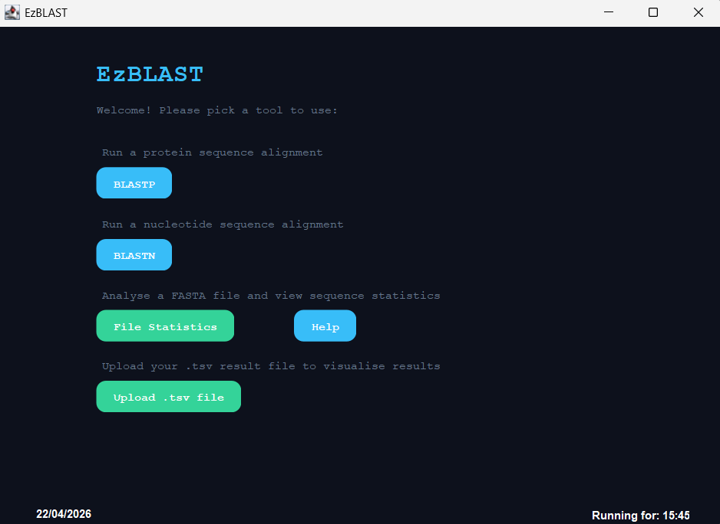
The BlastN output page pops up.
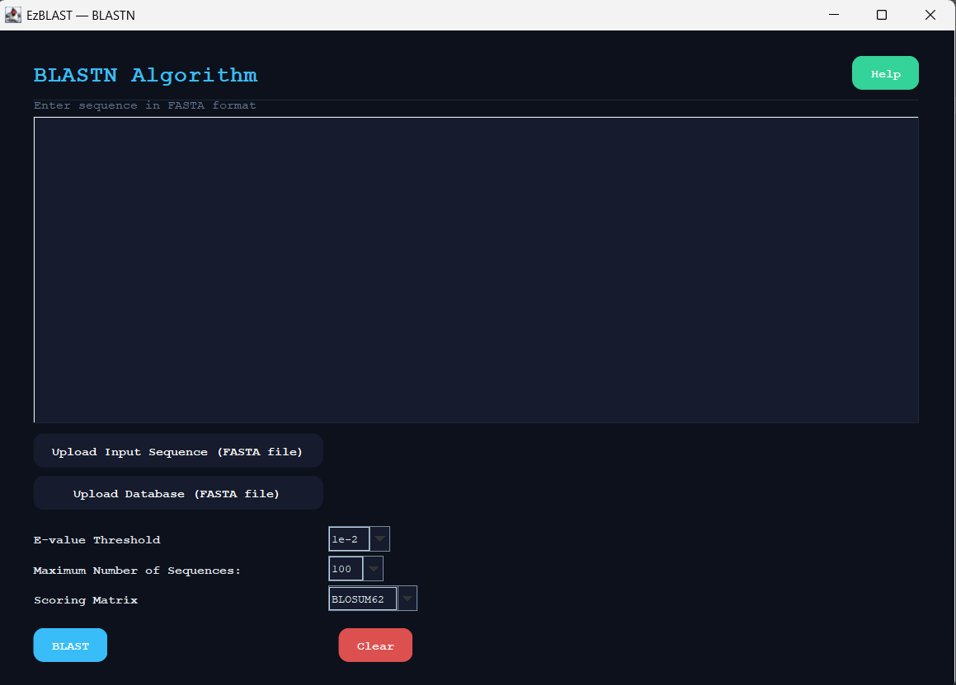
User inputs nucleotide sequence
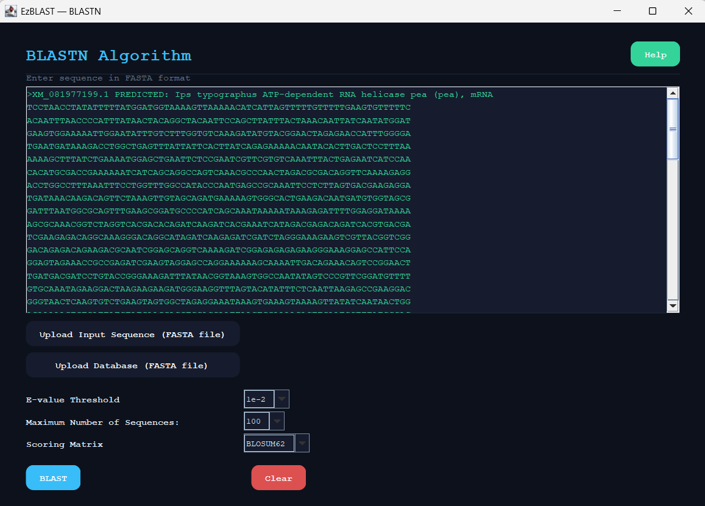
User uploads their own nucleotide database using the upload database button, pop up message appears if not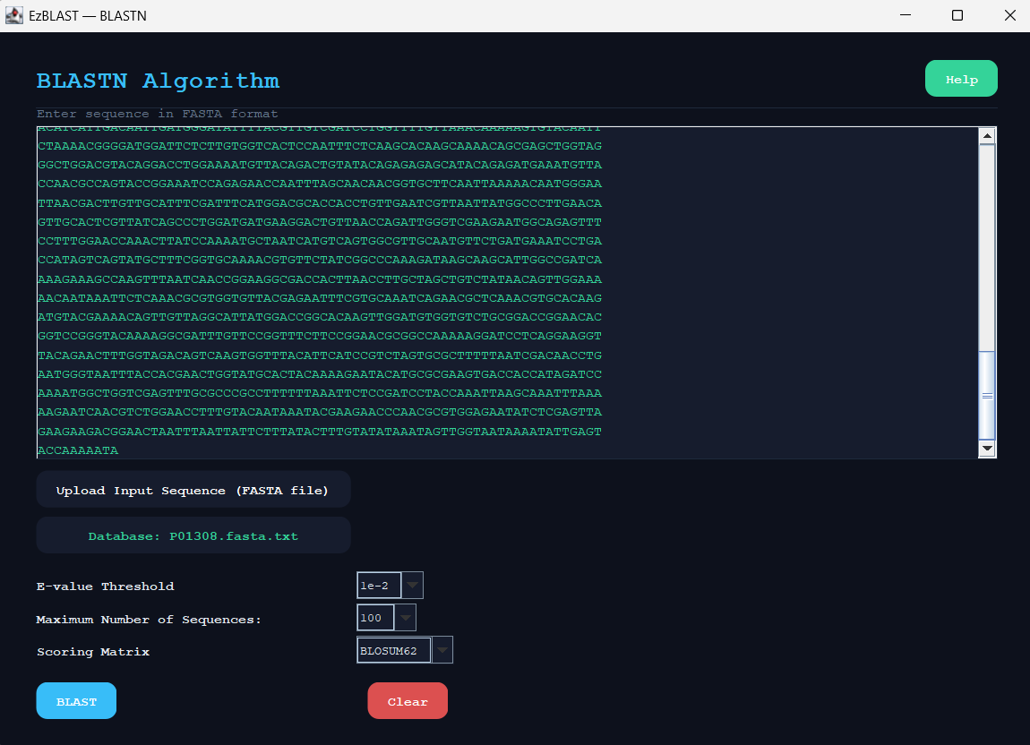
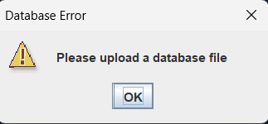
User can see their output, and also export results
